CAR RENTAL SYSTEM

project:
Debasish parida (25bai10081)
2025
Car Rental System: Project Report
2. Introduction
This report documents the design, implementation, and testing of the Car Rental System, a console-based application built in Python. The system is designed to manage a fleet of vehicles, track their availability, handle customer rental and return transactions, and calculate rental costs. It provides a simple, interactive user interface suitable for a small-scale, internal car rental operation management.
3. Problem Statement
The core problem addressed is the inefficient manual tracking of car inventory and rental transactions within a small-scale rental business. Without a centralized system, it is difficult to accurately determine which cars are available, who currently possesses which vehicle, and to calculate rental costs quickly and reliably. The solution requires an automated system to manage car status and active customer rentals efficiently.
4. Functional Requirements
ID | Requirement | Description
FR1.0 | Car Inventory Management | The system must maintain a dynamic list of cars with attributes (Make, Model, ID, Availability).
FR1.1 | Add Car | Users (Admin) must be able to add a new car to the inventory.
FR2.0 | View Available Cars | The system must display a list of all cars currently marked as available for rent.
FR3.0 | Rent Car Transaction | The system must allow a customer to rent an available car for a specified number of days, marking the car as unavailable and creating an active rental record.
FR3.1 | Cost Calculation | The system must calculate and display the estimated rental cost based on the daily rate and rental duration.
FR4.0 | Return Car Transaction | The system must allow a customer to return a rented car, removing the active rental record and marking the car as available.
FR5.0 | View Active Rentals | The system must display a list of all ongoing rentals, including the customer name, car ID, and rental duration.
FR6.0 | User Interface | The system must provide a simple, menu-driven command-line interface for interaction.
5. Non-functional Requirements
ID | Requirement | Description
NFR1.0 | Usability | The command-line interface must be intuitive, with clear menus and prompts.
NFR2.0 | Error Handling | The system must gracefully handle invalid inputs (e.g., non-numeric IDs, empty fields) during transactions.
NFR3.0 | Maintainability | The code must be well-organized into logical classes (CarManager, RentalManager, UserInterface) following Object-Oriented Programming (OOP) principles.
NFR4.0 | Reliability | Car availability status must be correctly synchronized between the inventory and active rentals.
6. System Architecture
The Car Rental System utilizes a Tiered Monolithic Architecture consisting of three main logical components (Python classes):
- Data/Service Layer (CarManager): Responsible for managing the core inventory data (car information, availability status) and providing data access methods (add, check, update).
- Business Logic Layer (RentalManager): Encapsulates the transactional logic (renting, returning, cost calculation) and relies on the CarManager for inventory updates.
- Presentation Layer (UserInterface): Provides the command-line interface, handles user input, displays menus, and orchestrates calls to the RentalManager and CarManager.
This design separates concerns, making the logic easy to test and maintain.
7. Design Diagrams
Use Case Diagram
The Use Case Diagram illustrates the system's functions from the perspective of the primary actors: the Customer and the Admin (implicitly the user accessing admin functions).
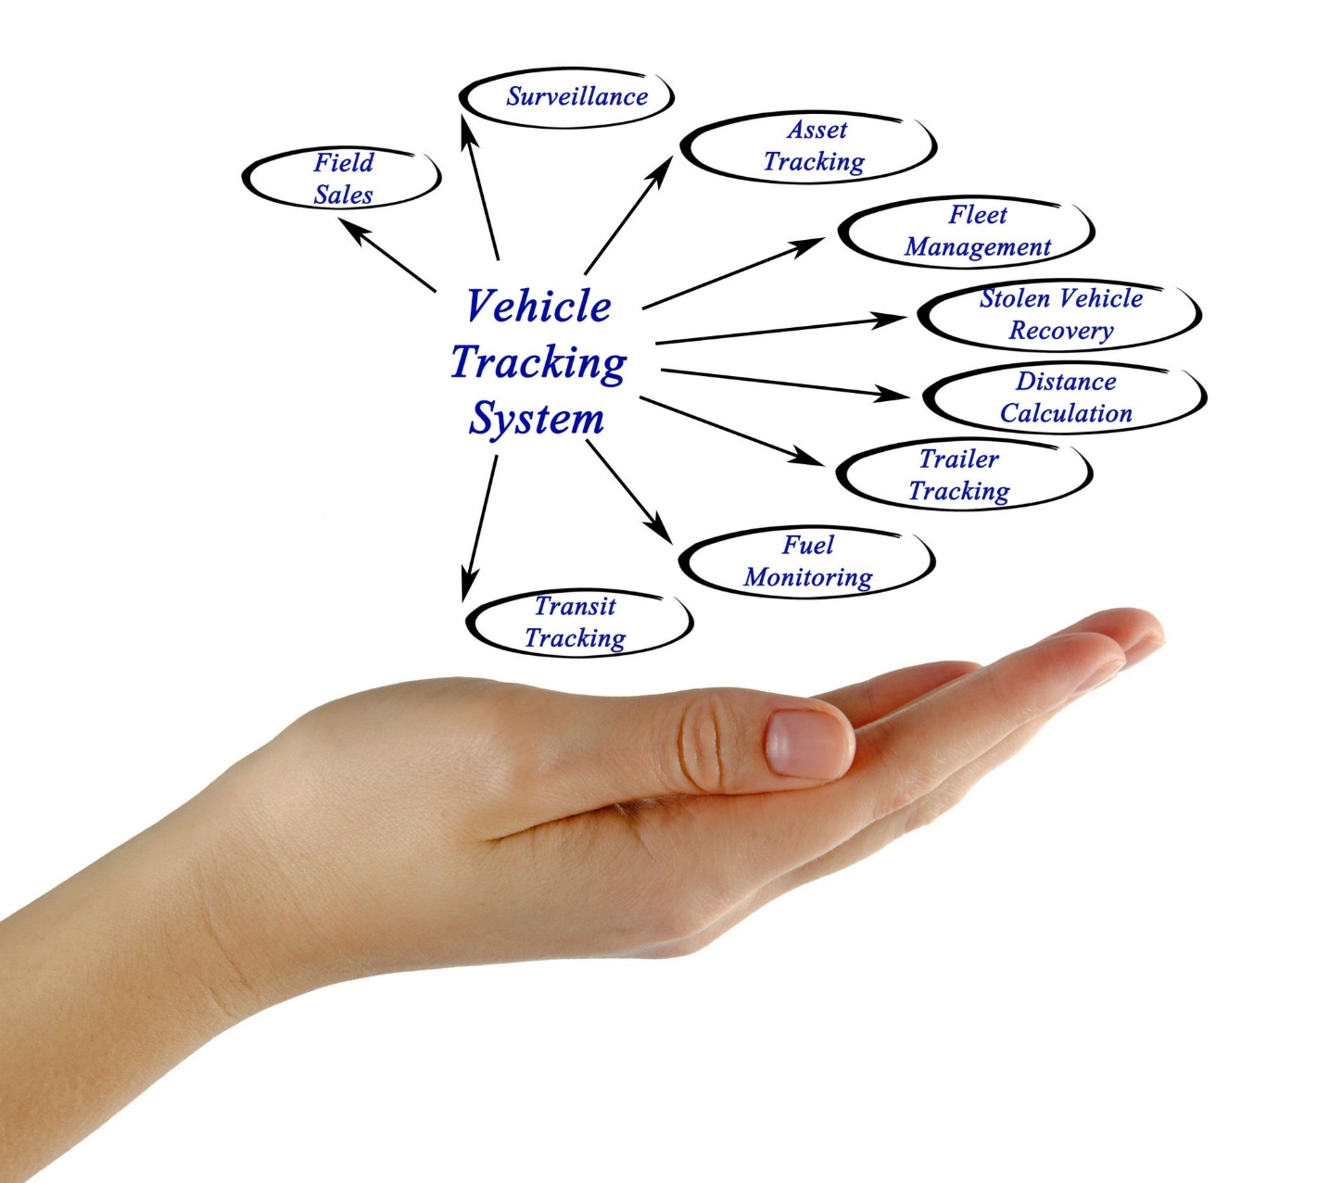
Getty Images
Workflow Diagram
The Workflow Diagram visualizes the steps involved in the primary business process: renting a car.
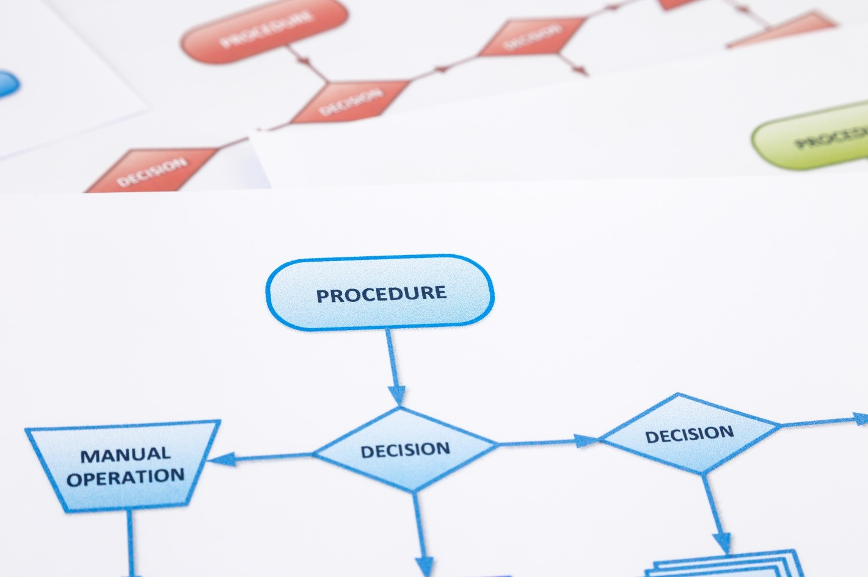
Shutterstock
Explore
Sequence Diagram
The Sequence Diagram demonstrates the interaction and order of messages between the UserInterface, RentalManager, and CarManager during the "Rent a Car" transaction.
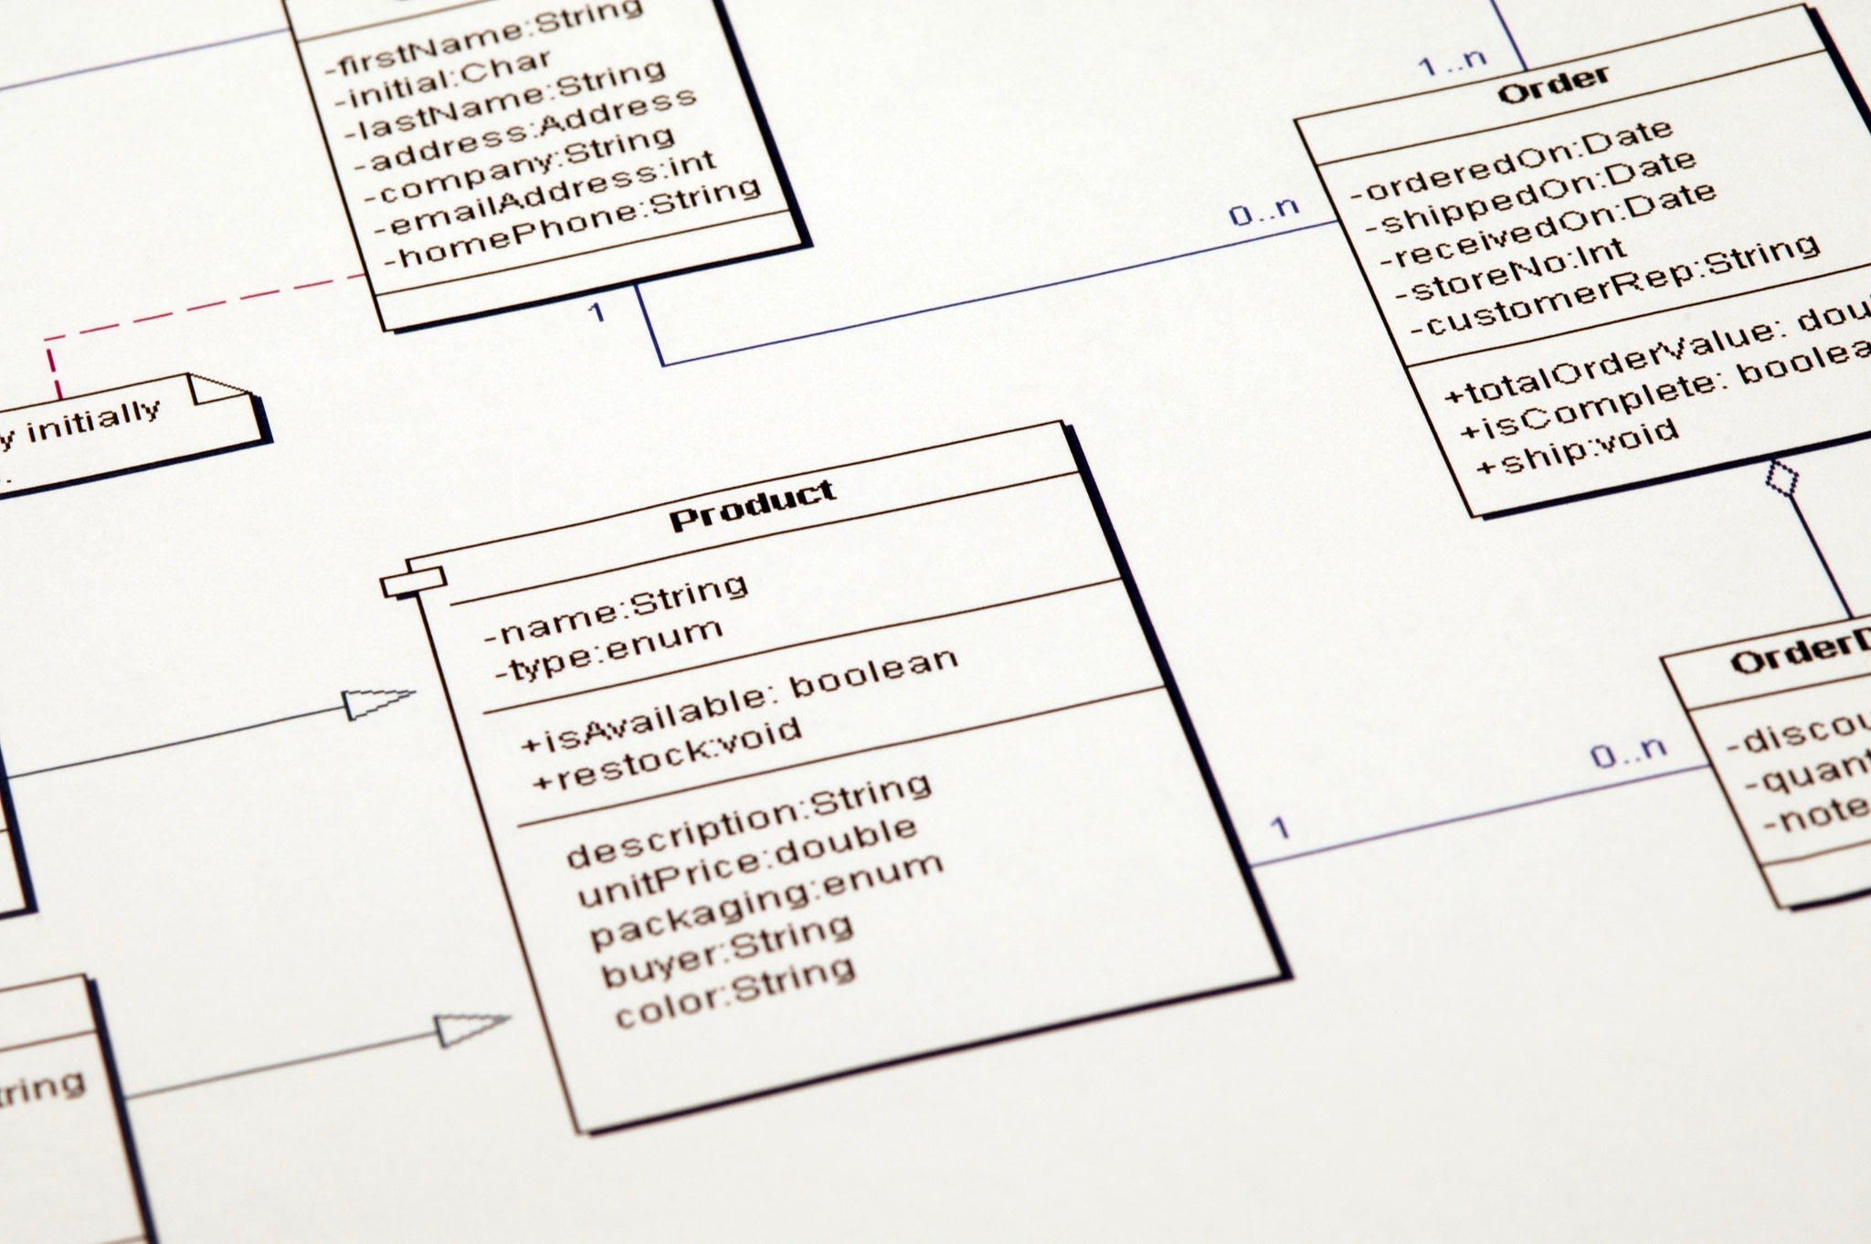
Getty Images
Explore
Class/Component Diagram
This diagram shows the main components (classes) and their relationships, illustrating the OOP structure of the application.
- CarManager: Manages the inventory dictionary.
- RentalManager: Depends on (aggregates) CarManager to perform rental transactions, manages the active_rentals dictionary.
- UserInterface: Depends on both managers to run the application logic and interact with the user.
ER Diagram (Conceptual Data Model)
Although the storage uses in-memory Python dictionaries, the conceptual data model can be mapped as follows:
- CAR Entity:
  - Attributes: Car ID (PK), Make, Model, Available (Boolean)
- RENTAL Entity:
  - Attributes: Customer Name (PK/Identifier), Car ID (FK to CAR), Rental Days
The relationship between CAR and RENTAL is 1-to-Many, where one car can be part of many past rental transactions, but at any given time, a car is either available or tied to at most one active rental. (In the current code, the active_rentals dictionary enforces the 1:1 active relationship by using customer_name as the key, implicitly linking one customer to one currently rented car).
8. Design Decisions & Rationale
Decision | Rationale
OOP Structure | Separating inventory management (CarManager) from transaction logic (RentalManager) ensures a clean Separation of Concerns. The RentalManager only needs to know that a car can be checked/updated, not how the inventory is stored.
In-Memory Dictionary Storage | Using Python dictionaries (self.inventory, self.active_rentals) allows for fast prototyping and simplifies the implementation for a command-line application, as persistence is not a requirement of the initial design.
Integer Car IDs | Using sequential integers (next_car_id) as primary keys for the cars simplifies user input and dictionary lookups.
Input Validation & Error Handling | Implemented try-except blocks (e.g., in check_availability, rent_car) and input checks (e.g., ensuring fields are not empty) to make the application robust against user errors.
9. Implementation Details
The system is implemented entirely in Python, using standard libraries.
- CarManager:
  - The inventory dictionary uses the car ID as the key for quick access.
  - The add_car method uses self.next_car_id to ensure unique, sequential IDs.
- RentalManager:
  - The active_rentals dictionary uses the customer_name as the key, enforcing that one customer can only have one active rental at a time. The value is a tuple of (car_id, rental_days).
  - The rent_car method orchestrates the availability check, updates the car status via CarManager, and records the rental.
- UserInterface:
  - Contains the main run() loop and helper methods (_handle_rent_car, etc.) to manage user interaction flow.
11. Testing Approach
Testing was conducted manually using the console interface (black-box testing) and through unit-like checks (white-box testing) by directly calling class methods.
Key Test Cases:
Test Case | Steps | Expected Result
T1: Successful Rental | 1. View Available Cars (e.g., ID 1). 2. Rent Car ID 1. | Car ID 1 is marked unavailable; Rental record created; Cost displayed.
T2: Rent Unavailable Car | 1. Attempt to rent car ID 3 (initially unavailable). | Error message displayed; Car ID 3 remains unavailable.
T3: Successful Return | 1. Rent Car ID 2. 2. Return Car for that customer. | Rental record removed; Car ID 2 is marked available.
T4: Invalid Input | Attempt to rent a car using non-numeric ID or days. | Error message displayed; No changes to inventory or rentals.
12. Challenges Faced
The primary challenge was ensuring transactional integrity, specifically:
- Synchronization: Ensuring that when a car is rented, its status in the CarManager's inventory is atomically updated to False before or immediately after recording the rental in RentalManager. This was solved by making the RentalManager directly call CarManager.update_availability().
- Unique Rental: The decision to key active_rentals by customer_name was made to prevent a single customer from renting multiple cars, which simplified the return_car process since only the customer name is required for lookup.
13. Learnings & Key Takeaways
- OOP Design: The use of distinct, collaborative classes (Manager objects) demonstrated how to effectively model real-world business domains in code, making the system modular and easier to read.
- Encapsulation: The RentalManager is successfully encapsulated from the internal data structure of CarManager, relying only on its public methods (check_availability, update_availability).
- Robust Input: The necessity of strong input validation and try-except blocks in a console application became clear to handle unexpected user entries (e.g., strings where integers are expected).
14. Future Enhancements
- Persistence: Implement a database (e.g., SQLite, PostgreSQL, or even JSON/CSV file storage) to save inventory and rental data across sessions.
- Customer Management: Introduce a separate CustomerManager class to handle customer registration, verification, and history.
- Pricing Models: Introduce variable pricing based on car make/model/type instead of a single static DAILY_RATE.
- Admin Functions: Add functionality to remove cars, modify car details, and generate reports (e.g., total revenue).
- GUI: Develop a graphical user interface (GUI) using libraries like Tkinter or PyQt to improve usability beyond the command line.
15. References
- Python Standard Library Documentation (for basic data structures and IO).
- Object-Oriented Programming (OOP) principles for class design.
Screenshots:
